1. Business Process for Adding New Data:

The book database will primarily accumulate data through the following processes:

a) Adding New Books:

- When a new book is published or added to the inventory, it's entered into the 'books' table.

- Associated data like authors, genres, and publisher information are added to their respective tables if they don't already exist.

- An ISBN is assigned and added to the 'isbns' table.

b) Updating Book Information:

- Existing book entries may be updated with new information (e.g., price changes, description updates).

c) Recording Ratings:

- As readers rate books, new entries are added to the 'ratings' table.

d) Adding New Authors, Publishers, or Genres:

- When new entities are introduced, they are added to their respective tables.

2. Transaction Table for Data Accumulation:

To track the gradual accumulation of data over time, we'll introduce a new 'transactions' table:

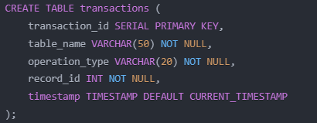

This table will record:

- Which table was affected (table_name)

- Type of operation (INSERT, UPDATE, DELETE)

- ID of the affected record

- Timestamp of the transaction

3. Implementation Process:

a) Database Triggers:

- Create triggers on main tables (books, authors, publishers, ratings, etc.) to automatically insert a record into the 'transactions' table whenever a change occurs.

b) Example Trigger for the 'books' table:

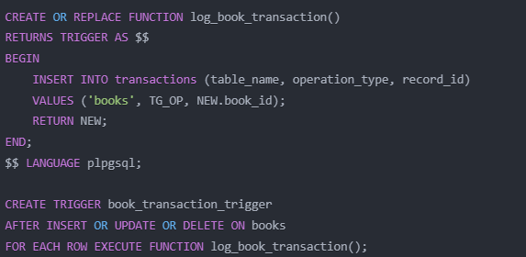

c) Application Layer:

- Implement logic in the application to handle data input and updates.

- Ensure that all database operations are properly logged through the trigger system.

4. Data Accumulation Over Time:

- New books, authors, and publishers will be added as they enter the market.

- Ratings and reviews will accumulate as readers interact with books.

- Price updates and other changes will be recorded as they occur.

- The 'transactions' table will provide a chronological record of all changes, allowing for analysis of data growth and change patterns over time.

This system ensures that all data changes are tracked with timestamps, providing a comprehensive history of the database's evolution over time. It allows for auditing, trend analysis, and understanding the growth patterns of the book database.